PHP – Hausübung 5

inc_db_config.php

<?php  
  
*define*('DB_SERVER', 'localhost');  
*define*('DB_USERNAME', 'kwm226hue05');  
*define*('DB_PASSWORD', '.kwm.');  
*define*('DB_DATABASE', 'kwm226_ue05_schickmair');  
  
?>

index.php

<?php  
*session_name*("sess_kwm226_hue05");  
*session_start*();  
  
*spl_autoload_register*(function ($sClassname) {  
 require_once($sClassname.".php");  
});  
  
Database::*loadConfig*("inc_db_config.php");  
?>  
  
<!doctype html>  
<html lang="en">  
<head>  
 <meta charset="UTF-8">  
 <title>ToDoList</title>  
 <link rel="stylesheet" type="text/css" href="css/style.css"/>  
 *<!-- CSS only -->* <link href="https://cdn.jsdelivr.net/npm/bootstrap@5.0.1/dist/css/bootstrap.min.css" rel="stylesheet" integrity="sha384-+0n0xVW2eSR5OomGNYDnhzAbDsOXxcvSN1TPprVMTNDbiYZCxYbOOl7+AMvyTG2x" crossorigin="anonymous">  
</head>  
<body>  
<?php

*//Login and Registration Process incl. Error-Handling*$errors = [];  
if(!isset($_SESSION["user"])){  
 *//case user is not logged in* if(isset($_REQUEST["action"]) && $_REQUEST["action"] == "login"){  
 *//case user wants to log in* if(isset($_REQUEST["username"])  
 && isset($_REQUEST["password"])  
 && $_REQUEST["username"] != ""  
 && $_REQUEST["password"] != ""  
 && checkLogin($_REQUEST["username"], $_REQUEST["password"])){  
  
 *//case user data is correct* $_SESSION["user"] = array("username" => $_REQUEST["username"],  
 "userid" => getUserId($_REQUEST["username"]));  
 showData($_SESSION["user"]["userid"]);  
 showTaskForm();  
 showLogoutForm();  
 }  
 else{  
 *//case user data is incorrect* echo("<div class='notify red'>Login data incorrect!</div>");  
 showLoginForm();  
 showRegistrationForm();  
 }  
 }  
 else if(isset($_REQUEST["action"]) && $_REQUEST["action"] == "register"){  
 *//case user wants to register* if(checkRegistration() && usernameAvailable($_REQUEST["usernamereg"])){  
 *//data correct* register($_REQUEST["usernamereg"], $_REQUEST["password1"], $_REQUEST["email"]);  
 echo "<div class='notify green'>Successfully registered! You can now login with the username ".$_REQUEST["usernamereg"]."</div><br>";  
 }  
 else{  
 *//data incorrect* echo("<div class='notify red'>Registration data not correct!</div>");  
 }  
 showLoginForm();  
 showRegistrationForm();  
 }  
 else{  
 *//case user wants to view page* showLoginForm();  
 showRegistrationForm();  
 }  
}  
*//case user is logged in*else {  
*//case user creates new task* if (isset($_REQUEST["action"]) && $_REQUEST["action"] == "addTasks") {  
 if (titleAvailable($_REQUEST["addTitle"]) && checkAddEntry()) {  
 createTask($_SESSION["user"]["userid"], $_REQUEST["addTitle"], $_REQUEST["addNote"]);  
 echo("<div class='notify green'>New task created.</div>");  
 }  
 else{  
 echo("<div class='notify red'>Task could not be created - incorrect/duplicate content.</div>");  
 }  
 showData($_SESSION["user"]["userid"]);  
 showTaskForm();  
 showLogoutForm();  
 }  
 *//case user wants to logout* else if (isset($_REQUEST["action"]) && $_REQUEST["action"] == "logout") {  
 unset($_SESSION["user"]);  
 showLoginForm();  
 showRegistrationForm();  
 }  
 *//case user wants to edit a task* else if(isset($_REQUEST["action"]) && $_REQUEST["action"] == "edittask"){  
 if(isset($_REQUEST["entryid"])) {  
 $_SESSION["task"] = $_REQUEST["entryid"];  
 }  
 else{  
 echo("<div class='notify red'>Task could not be edited.</div>");  
 }  
 showData($_SESSION["user"]["userid"]);  
 showEditForm(getEditData($_REQUEST["entryid"], $_SESSION["user"]));  
 showLogoutForm();  
 }  
 *//case user wants to submit Edit-Form* else if(isset($_REQUEST["action"]) && $_REQUEST["action"] == "editTaskSubmit") {  
 if (checkEditEntry()) {  
 if (editTask($_SESSION["task"], $_SESSION["user"])) {  
 echo("<div class='notify green'>Task successfully edited.</div>");  
 } else {  
 echo("<div class='notify red'>Task could not be edited.</div>");  
 }  
 showData($_SESSION["user"]["userid"]);  
 showTaskForm();  
 showLogoutForm();  
 }  
 else {  
 showData($_SESSION["user"]["userid"]);  
 showEditForm(getEditData($_SESSION["task"], $_SESSION["user"]));  
 showLogoutForm();  
 }  
 }  
 *//case user wants to delete task* else if(isset($_REQUEST["action"]) && $_REQUEST["action"] == "deletetask"){  
 if(isset($_REQUEST["entryid"])){  
 if(deleteTask($_REQUEST["entryid"], $_SESSION["user"])){  
 echo("<div class='notify green'>Task was successfully deleted.</div>");  
 }  
 else{  
 echo("<div class='notify red'>Task could not be deleted.</div>");  
 }  
 }  
 showData($_SESSION["user"]["userid"]);  
 showTaskForm();  
 showLogoutForm();  
 }  
 *//case user wants to finish task* else if(isset($_REQUEST["action"]) && $_REQUEST["action"] == "finishtask"){  
 if(isset($_REQUEST["entryid"])){  
 if(finishTask($_REQUEST["entryid"], $_SESSION["user"])){  
 echo("<div class='notify green'>Task was successfully finished.</div>");  
 }  
 else{  
 echo("<div class='notify red'>Task could not be finished.</div>");  
 }  
 }  
 showData($_SESSION["user"]["userid"]);  
 showTaskForm();  
 showLogoutForm();  
 }

*//case user wants to open task* else if(isset($_REQUEST["action"]) && $_REQUEST["action"] == "opentask"){  
 if(isset($_REQUEST["entryid"])){  
 if(openTask($_REQUEST["entryid"], $_SESSION["user"])){  
 echo("<div class='notify green'>Task was successfully opened.</div>");  
 }  
 else{  
 echo("<div class='notify red'>Task could not be opened.</div>");  
 }  
 }  
 showData($_SESSION["user"]["userid"]);  
 showTaskForm();  
 showLogoutForm();  
 }  
 *//case user wants to view page* else {  
 showData($_SESSION["user"]["userid"]);  
 showTaskForm();  
 showLogoutForm();  
 }  
}  
  
*//getEditData()  
//Fetches the entry-data of the old entry to show it in the edit-form.*function getEditData(int $taskID, array $user){  
 $userQuery = "SELECT creatorid FROM todolist_item WHERE entryid=".$taskID.";";  
 $taskOwner = Database::*selectQuery*($userQuery)->fetch_assoc()['creatorid'];  
  
 if($taskOwner == $user['userid'] || isAdmin($user['userid'])){  
 $deleteQuery = "SELECT title, text, entryid FROM todolist_item WHERE entryid = ".$taskID.";";  
 $row = Database::*selectQuery*($deleteQuery)->fetch_assoc();  
 if($row){  
 return $row;  
 }  
 return null;  
 }  
 else return null;  
}  
  
*//editTask()  
//Checks if there are only allowed chars (escaped) to avoid SQL injection.  
//Updates the DB row with new values.*function editTask(int $taskID, array $user){  
 $escaped = Database::*realEscape*($_REQUEST["editTitle"], $_REQUEST["editNote"]);  
 $userQuery = "SELECT creatorid FROM todolist_item WHERE entryid=".$taskID.";";  
 $taskOwner = Database::*selectQuery*($userQuery)->fetch_assoc()['creatorid'];  
  
 if($taskOwner == $user['userid'] || isAdmin($user['userid'])){  
 $editQuery1 = "UPDATE todolist_item   
 SET title = '".$escaped["val1"]."',   
 text='".$escaped["val2"]."' ,  
 editorid=".$_SESSION["user"]["userid"].",  
 editdate='".*date*("Y-m-d")."'  
 WHERE entryid=".$taskID.";";  
 if(Database::*updateQuery*($editQuery1)){  
 return true;  
 }  
 return false;  
 }  
 else return false;  
}

*//deleteTask()  
//Deletes a task if the user is allowed to (creator or admin).  
//Deletes the row in the todolist-item table.*function deleteTask(int $taskID, array $user){  
 $userQuery = "SELECT creatorid FROM todolist_item WHERE entryid=".$taskID.";";  
 $taskOwner = Database::*selectQuery*($userQuery)->fetch_assoc()['creatorid'];  
  
 if($taskOwner == $user['userid'] || isAdmin($user['userid'])){  
 $deleteQuery = "DELETE FROM todolist_item WHERE entryid=".$taskID.";";  
 if(Database::*deleteQuery*($deleteQuery)){  
 return true;  
 }  
 return false;  
 }  
 else return false;  
}  
  
*//openTask()  
//Opens a task if the user is allowed to (creator or admin).  
//Updates the row in the todolist-item table -> status "aktiv".*function openTask(int $taskID, array $user){  
 $userQuery = "SELECT creatorid FROM todolist_item WHERE entryid=".$taskID.";";  
 $taskOwner = Database::*selectQuery*($userQuery)->fetch_assoc()['creatorid'];  
  
 if($taskOwner == $user['userid'] || isAdmin($user['userid'])){  
 $finishQuery = "UPDATE todolist_item SET status = 'aktiv' WHERE entryid=".$taskID.";";  
 if(Database::*updateQuery*($finishQuery)){  
 return true;  
 }  
 return false;  
 }  
 else return false;  
}  
  
*//finishTask()  
//Opens a task if the user is allowed to (creator or admin).  
//Updates the row in the todolist-item table -> status "abgeschlossen".*function finishTask(int $taskID, array $user){  
 $userQuery = "SELECT creatorid FROM todolist_item WHERE entryid=".$taskID.";";  
 $taskOwner = Database::*selectQuery*($userQuery)->fetch_assoc()['creatorid'];  
  
 if($taskOwner == $user['userid'] || isAdmin($user['userid'])){  
 $finishQuery = "UPDATE todolist_item SET status = 'abgeschlossen' WHERE entryid=".$taskID.";";  
 if(Database::*updateQuery*($finishQuery)){  
 return true;  
 }  
 return false;  
 }  
 else return false;  
}

*//createTask()  
//Creates a new task in the database*function createTask(int $creatorid, string $title, string $text){  
 $escaped = Database::*realEscape*($title, $text);  
 $insertQuery = "INSERT INTO todolist_item (creationdate, creatorid, title, text)   
 VALUES ('".*date*("Y-m-d")."', '".$creatorid."', '".$escaped["val1"]."', '".$escaped["val2"]."');";  
 $taskID = Database::*insertQuery*($insertQuery);  
  
 if($taskID != 0){  
 $insertQuery2 = "INSERT INTO user_item (entryid, userid) VALUES (".$taskID.", ".$creatorid.");";  
 Database::*insertQuery*($insertQuery2);  
 return true;  
 }  
 return false;  
}  
  
  
*//getUserId()  
//Gets the UserId of a user with a certain, unique username.*function getUserId(string $username){  
 $escaped = Database::*realEscape*($username);  
 $selectQuery = "SELECT userid FROM user WHERE username='".$escaped["val1"]."';";  
 $result = Database::*selectQuery*($selectQuery);  
 if($row = $result->fetch_assoc()){  
 return $row["userid"];  
 }  
 else return null;  
}  
  
*//usernameAvailable()  
//Checks if the entered username in the registration form is already taken or not.*function usernameAvailable(string $username){  
 $escaped = Database::*realEscape*($username);  
 $selectQuery = "SELECT username FROM user WHERE username='".$escaped["val1"]."';";  
 $result = Database::*selectQuery*($selectQuery);  
  
 if($result->num_rows < 0){  
 return false;  
 }  
 return true;  
}  
  
*//isAdmin()  
//Checks if recent user has the role admin in the database*function isAdmin(int $userID):bool{  
 $selectQuery = "SELECT role FROM user  
 WHERE userid = " . $userID . ";";  
  
 $data = Database::*selectQuery*($selectQuery);  
 $row = *mysqli_fetch_assoc*($data);  
 if($row["role"] != 1)  
 return false;  
 else  
 return true;  
}

*//register()  
//This function allows a new user to register by entering all  
//data needed. If the user wants to register with a already  
//existing username, a error message shows up.*function register(string $username, string $password, string $email):bool{  
 $escaped = Database::*realEscape*($username, $email);  
 $insertQuery = "INSERT into user (username, password, email)   
 VALUES ('".$escaped["val1"]."',   
 '".*md5*($password)."',   
 '".$escaped["val2"]."');";  
 $id = Database::*insertQuery*($insertQuery);  
  
 if($id != 0)  
 return true;  
 return false;  
}  
  
*//titleAvailable()  
//Checks if the title of the task is already used.*function titleAvailable(string $title){  
 $selectQuery = "SELECT title FROM todolist_item   
 WHERE creatorid='" .$_SESSION["user"]["userid"]."'  
 AND title='".$title."';";  
  
 $result = Database::*selectQuery*($selectQuery);  
  
 if($result->num_rows > 0){  
 return false;  
 }  
 return true;  
}  
  
*//checkAddEntry()  
//Checks the input fields of the form to add new tasks*function checkAddEntry():bool{  
 global $errors;  
 if(!isset($_REQUEST["addTitle"]) || *strlen*($_REQUEST["addTitle"]) < 6)  
 $errors["addTitle"] = "<i>Title must be at least 6 characters long!</i>";  
  
 if(*count*($errors) > 0)  
 return false;  
 return true;  
}  
  
*//checkEditEntry()  
//Checks the input fields of the form to edit tasks*function checkEditEntry():bool{  
 global $errors;  
 if(!isset($_REQUEST["editTitle"]) || *strlen*($_REQUEST["editTitle"]) < 6)  
 $errors["editTitle"] = "<i>Title must be at least 6 characters long!</i>";  
  
 if(*count*($errors) > 0)  
 return false;  
 return true;  
}

*//checkLogin()  
//Checks the input fields of the login form by comparing it with the saved data of the userList.  
//Only if username and password are correct, the user can login.*function checkLogin(string $username, string $password):bool{  
 $escaped = Database::*realEscape*($username, $password);  
 $selectQuery = "SELECT username FROM user WHERE username='".$escaped["val1"]."' AND password='".*md5*($password)."';";  
 $result = Database::*selectQuery*($selectQuery);  
 if($result->num_rows > 0){  
 return true;  
 }  
 else {  
 global $errors;  
 *//username* if (!isset($_REQUEST["username"]))  
 $errors["username"] = "<br><i>Please enter valid username.</i>";  
 *//password* if (!isset($_REQUEST["password"]))  
 $errors["password"] = "<br><i>Please enter valid password.</i>";  
 return false;  
 }  
}  
  
*//checkRegistration()  
//Checks if various rules of the input fields of the registration form  
//are followed. Otherwise the errors will be saved.*function checkRegistration():bool{  
 global $errors;  
 *//username* if(!isset($_REQUEST["usernamereg"]) || *strlen*($_REQUEST["usernamereg"]) < 6)  
 $errors["usernamereg"] = "<br><i>Username must be at least 6 characters long</i>";  
  
 *//password* if(!isset($_REQUEST["password1"]) ||  
 !isset($_REQUEST["password2"]) ||  
 $_REQUEST["password1"] != $_REQUEST["password2"] ||  
 *strlen*($_REQUEST["password1"]) < 8)  
 $errors["password1"] = "<br><i>Password must be at least 8 characters long and must match</i>";  
  
 *//email* if(!isset($_REQUEST["email"]) || *filter_var*($_REQUEST["email"], *FILTER_VALIDATE_EMAIL*) === false)  
 $errors["email"] = "<br><i>Must be a valid email address</i>";  
  
 if(*count*($errors) > 0)  
 return false;  
 return true;  
}

*//showData()  
//This function prints the TodoList. Only tasks of the  
//user who is logged in will be shown, all other tasks wont be  
//visible for this user. (admin sees all tasks)*function showData($userID)  
{  
 if (!isAdmin($userID))  
 $selectQuery = "SELECT *\** FROM todolist_item WHERE creatorid = " . $userID . ";";  
 else  
 $selectQuery = "SELECT *\** FROM todolist_item;";  
  
 $data = Database::*selectQuery*($selectQuery);  
 $todolist = new TodoList($_SESSION["user"]["userid"], $_SESSION["user"]["username"]);  
  
 while ($row = $data->fetch_assoc()) {  
 $todolistitem = new TodoListItem($row["entryid"], $row["creationdate"], $row["creatorid"], $row["title"], $row["editdate"], $row["text"], $row["status"], $row["editorid"]);  
 *array_push*($todolist->entries, $todolistitem);  
 }  
 echo $todolist;  
}  
  
*//showTaskForm()  
//Output of the TaskForm - if errors occur, the incorrect fields  
//will be highlighted and the error will be described*function showTaskForm(){  
 global $errors;  
 $title = "";  
  
 if(isset($_REQUEST["addTitle"]) && *count*($errors) > 0){  
 $title = $_REQUEST["addTitle"];  
 }  
 ?>  
  
 <div class="form-style-5">  
 <form action="<?php echo($_SERVER['PHP_SELF']);?>" method="post">  
 <fieldset>  
 <legend><span class="number">+</span>Eintrag hinzufügen</legend>  
 <?php  
 if(isset($errors["addTitle"])){  
 echo('<input type="text" name="addTitle" id="addTitle" placeholder="Titel*" class="error" value="'.$title.'">');  
 echo($errors["addTitle"]);  
 }  
 else echo('<input type="text" name="addTitle" id="addTitle" placeholder="Titel*" value="'.$title.'">');  
  
 if(isset($_REQUEST["addNote"]) && *count*($errors) > 0){  
 $desc = $_REQUEST["addNote"];  
 echo('<textarea name="addNote" id="addNote">'.$desc.'</textarea>');  
 }  
 else echo('<textarea name="addNote" id="addNote" placeholder="Beschreibung"></textarea>');  
 ?>  
 </fieldset>  
 <input type="hidden" name="action" value="addTasks">  
 <input type="submit" id="addTasks" value="Eintrag hinzufügen">  
 </form>  
 </div>  
 <?php  
}  
  
*//showEditForm()  
//Output of the EditForm - if errors occur, the incorrect fields  
//will be highlighted and the error will be described*function showEditForm(array $row){  
 global $errors;  
 $title = "";  
  
 if(isset($_REQUEST["editTitle"]) && *count*($errors) > 0){  
 $title = $_REQUEST["editTitle"];  
 }  
 ?>  
  
 <div class="form-style-5">  
 <form action="<?php echo($_SERVER['PHP_SELF']);?>" method="post">  
 <fieldset>  
 <legend><span class="number">!</span>Eintrag bearbeiten</legend>  
 <?php  
 if(isset($errors["editTitle"])){  
 echo('<input type="text" name="editTitle" id="editTitle" placeholder="Titel*" class="error" value="'.$title.'">');  
 echo($errors["editTitle"]);  
 }  
 else echo('<input type="text" name="editTitle" id="editTitle" placeholder="Titel*" value="'.$row["title"].'">');  
  
 if(isset($_REQUEST["editNote"]) && *count*($errors) > 0){  
 $desc = $_REQUEST["editNote"];  
 echo('<textarea name="editNote" id="editNote">'.$desc.'</textarea>');  
 }  
 else echo('<textarea name="editNote" id="editNote" placeholder="Beschreibung">'.$row["text"].'</textarea>');  
 ?>  
 </fieldset>  
 <input type="hidden" name="action" value="editTaskSubmit">  
 <input type="submit" id="editTasks" value="Eintrag ändern">  
 </form>  
 </div>  
 <?php  
}  
  
*//showRegistrationForm()  
//Output of the registration form - if errors occur, the incorrect fields  
//will be highlighted and the error will be described*function showRegistrationForm(){  
 global $errors;  
 $usernameVal = "";  
 $emailVal = "";  
  
 if(isset($_REQUEST["usernamereg"]) && *count*($errors) > 0){  
 $usernameVal = $_REQUEST["usernamereg"];  
 }  
 if(isset($_REQUEST["email"]) && *count*($errors) > 0){  
 $emailVal = $_REQUEST["email"];  
 }  
 ?>  
 <div class="registration_form">  
 <h3>Registrierung:</h3>  
 <form action="<?php echo($_SERVER['PHP_SELF']);?>" method="post">  
 <label for="usernamereg">Username:</label>  
 <?php  
 if(isset($errors["usernamereg"])){  
 echo('<input type="text" name="usernamereg" id="usernamereg" value="'.$usernameVal.'" class="error">');  
 echo($errors["usernamereg"]);  
 }  
 else  
 echo('<input type="text" name="usernamereg" id="usernamereg" value="'.$usernameVal.'">');  
 ?>  
 <br>  
 <label for="password1">Passwort:</label>  
 <?php  
 if(isset($errors["password1"])){  
 echo('<input type="password" name="password1" id="password1" class="error">');  
 echo($errors["password1"]);  
 }  
 else  
 echo('<input type="password" name="password1" id="password1">');  
 ?>  
 <br>  
 <label for="password2">Wiederholen:</label>  
 <input type="password" name="password2" id="password2"><br>  
 <label for="email">Email:</label>  
 <?php  
 if(isset($errors["email"])){  
 echo('<input type="email" name="email" id="email" class="error" value="'.$emailVal.'">');  
 echo($errors["email"]);  
 }  
 else echo('<input type="email" name="email" id="email" value="'.$emailVal.'">');  
 ?>  
 <br>  
 <input type="hidden" name="action" value="register">  
 <input type="submit" value="Registrieren" class="reg_button">  
 </form>  
 </div>  
 <?php  
}  
  
*//showLoginForm()  
//Output of the login form*function showLoginForm(){  
 global $errors;  
 $usernameVal = "";  
  
 if(isset($_REQUEST["username"]) && *count*($errors) > 0){  
 $usernameVal = $_REQUEST["username"];  
 }?>  
  
 <div class="login_form">  
 <h3>Login:</h3>  
 <form action="<?php echo($_SERVER['PHP_SELF']);?>" method="post">  
 <label for="username">Username:</label>  
 <?php  
 if(isset($errors["username"])){  
 echo('<input type="text" name="username" id="username"/>'.$usernameVal.'<br>');  
 echo($errors["username"]);  
 }  
 else echo('<input type="text" name="username" id="username"/><br>');  
 ?>  
 <label for="password">Passwort:</label>  
 <?php  
 if(isset($errors["password"])){  
 echo('<input type="password" name="password" id="password"/><br>');  
 echo($errors["username"]);  
 }  
 else echo('<input type="password" name="password" id="password"/><br>');  
 ?>  
 <input type="hidden" name="action" value="login">  
 <input type="submit" class="login_button" value="Login">  
 </form>  
 </div><?php  
}  
  
*//showLogoutForm()  
//Output of the logout button*function showLogoutForm(){ ?>  
 <form action="<?php echo($_SERVER['PHP_SELF']);?>" method="post">  
 <input type="hidden" name="action" value="logout">  
 <input type="submit" value="Logout" class="logout_button">  
 </form>  
 <?php  
}?>  
  
</body>  
</html>

Database.php

<?php  
  
  
class Database  
{  
 public static *$oMysqli*;  
  
 public static function loadConfig(string $sConfigFile)  
 {  
 require_once ($sConfigFile);  
 }  
  
 public static function deleteQuery(string $sQuery):bool  
 {  
 if (Database::*connect*())  
 {  
 $mResult = Database::*$oMysqli*->query($sQuery);  
 Database::*disconnect*();  
 return $mResult; *// result only tells us if the SQL statement could be processed and not if something was actually deleted* }  
 else  
 {  
 echo "Could not connect in deleteQuery!";  
 return false;  
 }  
 }  
  
 public static function insertQuery(string $sQuery):int  
 {  
 if (Database::*connect*())  
 {  
 $mResult = Database::*$oMysqli*->query($sQuery);  
 $iID = Database::*$oMysqli*->insert_id;  
 Database::*disconnect*();  
 return $iID; *// We return the id of the newly inserted row* }  
 else  
 {  
 echo "Could not connect in insertQuery!";  
 return 0;  
 }  
 }

public static function selectQuery(string $sQuery): ?mysqli_result  
 {  
 if (Database::*connect*())  
 {  
 $mResult = Database::*$oMysqli*->query($sQuery);  
 Database::*disconnect*();  
 return $mResult; *// a mysqli result object -> later fetch_assoc* }  
 else  
 {  
 echo "Could not connect in selectQuery!";  
 return null;  
 }  
 }  
  
 public static function updateQuery(string $sQuery):bool  
 {  
 if (Database::*connect*())  
 {  
 $mResult = Database::*$oMysqli*->query($sQuery);  
 Database::*disconnect*();  
 return $mResult; *// result only tells us if the SQL statement could be processed and not if something was actually deleted* }  
 else  
 {  
 echo "Could not connect in deleteQuery!";  
 return false;  
 }  
 }  
  
 public static function realEscape(string $val1, string $val2 = ""):array  
 {  
 if (Database::*connect*())  
 {  
 $aResult = array("val1" => Database::*$oMysqli*->real_escape_string($val1),  
 "val2" => Database::*$oMysqli*->real_escape_string($val2));  
 Database::*disconnect*();  
 return $aResult;  
 }  
 else  
 {  
 echo "Could not connect in realEscape!";  
 return [];  
 }  
 }

private static function connect():bool  
 {  
 Database::*$oMysqli* = @new mysqli(*DB_SERVER*, *DB_USERNAME*, *DB_PASSWORD*, *DB_DATABASE*);  
  
 if (Database::*$oMysqli*->connect_error)  
 {  
 return false;  
 }  
 return true;  
 }  
  
 private static function disconnect()  
 {  
 if (Database::*$oMysqli* != null)  
 {  
 Database::*$oMysqli*->close();  
 }  
 }  
}

TodoList.php

<?php  
  
  
class TodoList  
{  
 public function __construct(  
 private int $userId,  
 private string $username,  
 public array $entries = []  
 ) {  
 }  
  
 *//Getter* public function __get(string $entries):mixed  
 {  
 if (*property_exists*('TodoList', $entries)) {  
 return $this->{$entries};  
 } else throw new Exception("Attribute " . $entries . " does not exist in class TodoList!");  
 }  
  
 *//Setter* public function __set(string $entries, mixed $value):void  
 {  
 if (*property_exists*('TodoList', $entries)) {  
 $this->{$entries} = $value;  
 } else throw new Exception("Attribute " . $entries . " does not exist in class TodoList!");  
 }  
  
 *//Magic Method __toString() für die Ausgabe der  
 //TodoListe für den gerade angemeldeten User* public function __toString():string  
 {  
 $result="<div class='welcome'>\n  
 <h1>DEINE TO-DO LISTE</h1>\n  
 <h2>Hallo " . $this->username . "! (ID: ".$this->userId.")</h2>\n  
 </div>\n";  
 $result.="<div class='toDoList'>\n";  
  
 foreach($this->entries as $entry) {  
 $result .= $entry;  
 }  
  
 $result .= "\n</div>";  
 return $result;  
 }  
}

TodoListItem.php

<?php  
  
  
class TodoListItem  
{  
 public function __construct(  
 private string $entryId,  
 private string $creationDate,  
 private string $creatorId,  
 private string $title,  
 private mixed $editDate,  
 private string $text,  
 private string $status,  
 private mixed $editorId  
 )  
 {  
 }  
  
 *//Getter* public function __get(string $entry):mixed  
 {  
 if (*property_exists*('TodoListItem', $entry)) {  
 return $this->{$entry};  
 } else throw new Exception("Attribute " . $entry . " does not exist in class TodoListItem!");  
 }  
  
 *//Setter* public function __set(string $entry, mixed $mValue):void  
 {  
 if (*property_exists*('TodoListItem', $entry)) {  
 $this->{$entry} = $mValue;  
 } else throw new Exception("Attribute " . $entry . " does not exist in class TodoListItem!");  
 }  
  
 *//Magic Method __toString() für die Ausgabe der  
 //einzelnen Einträge in der TodoListe* public function __toString():string  
 {  
 $result = "\n<div id='".$this->entryId."' class='entry'>  
 <div class='status'>Status: ".$this->status."</div>  
 <h3 class='title'>Titel: ".$this->title."</h3>";  
  
 if($this->text != null)  
 $result .= "<p class='note'>".$this->text."</p>";  
  
 $result .= "<p>Ersteller-ID: ".$this->creatorId."</p>  
 <p>Erstellungsdatum: ".$this->creationDate."</p>";  
  
 *//Erst wenn eine Bearbeitung stattfand soll auch das  
 // Bearbeitungsdatum und die ID des Bearbeiters angezeigt werden* if($this->editorId != null) {  
 $result .= "<p>Letzter Bearbeiter-ID: " . $this->editorId . "</p>";  
 $result .= "<p>Letztes Bearbeitungsdatum: " . $this->editDate . "</p>";  
 }

$result .= "<div class='buttons'>\n";  
 if($this->status != "abgeschlossen") {  
 $result .= "<input type='hidden' name='action' value='edit'>";  
 $result .= "<a href='index.php?action=edittask&entryid=".$this->entryId."' class='edit' data-toogle='modal' data-target='#editModal'>Bearbeiten</a>";  
 $result .= "<input type='hidden' name='action' value='finish'>";  
 $result .= "<a href='index.php?action=finishtask&entryid=" . $this->entryId . "' class='finish'>Abschließen</a>";  
 }  
 else{  
 $result .= "<input type='hidden' name='action' value='open'>";  
 $result .= "<a href='index.php?action=opentask&entryid=" . $this->entryId . "' class='finish'>Aktivieren</a>";  
 }  
 $result .= "<input type='hidden' name='action' value='delete'>";  
 $result .= "<a href='index.php?action=deletetask&entryid=".$this->entryId."' class='delete'>Löschen</a>";  
 $result .= "\n</div>\n</div>";  
 return $result;  
 }  
  
}

style.css

body{  
 position: relative;  
 font-family: "Bahnschrift", sans-serif;  
 box-sizing: border-box;  
 background: url("../img/bg.jpg");  
}  
  
.welcome{  
 width: 100%;  
 background-color: #fff;  
 text-align: center;  
 color: #5e8949;  
 padding: 10px;  
 border-bottom: 8px solid #5e8949;  
}  
  
h1, h2{  
 margin: 0;  
 font-size: 28px !important;  
}  
  
.title{  
 text-align: left;  
 font-size: 18px !important;  
}  
  
.login_form, .registration_form{  
 position: absolute;  
 padding: 20px 50px 5px 50px;  
 background-color: white;  
 left: 35vw;  
 width: 400px;  
}  
  
.login_form{  
 top: 13vh;  
}  
  
.registration_form{  
 top: 43vh;  
 z-index: -1;  
}  
  
.registration_form h3{  
 z-index: 999;  
}

i{  
 color: red;  
}  
  
.notify{  
 top: 40px;  
 left: 20px;  
 position: absolute;  
 background-color: white;  
 font-size: 20px;  
}  
  
.red{  
 color: red;  
}  
  
.green{  
 color: green;  
}  
  
form input, form a{  
 box-sizing: border-box;  
 border-radius: 5px;  
 border: 1px solid #999;  
 padding: 4px;  
 outline: none;  
}  
  
.reg_button, .login_button, .logout_button{  
 font-size: 1.1em;  
 padding: 10px;  
 font-family: Roboto, sans-serif;  
 font-weight: 300;  
 color: #fff;  
 background-color: #5e8949;  
 border-radius: 20px;  
 cursor: pointer;  
 margin-bottom: 2em;  
 margin-top: 15px;  
}  
  
.logout_button{  
 position: absolute;  
 top: 10px;  
 right: 30px;  
}

.toDoList{  
 width: 100%;  
 padding: 2%;  
 display: flex;  
 gap: 50px;  
 flex-wrap: wrap;  
 justify-content: center;  
}  
  
.entry{  
 display: flex;  
 justify-content: space-evenly;  
 flex-direction: column;  
 background-color: #fff;  
 color: #5e8949;  
 padding: 30px;  
 border-radius: 20px;  
 font-size: 13px;  
 width: 400px;  
}  
  
.entry h3{  
 margin-bottom: 20px;  
}  
  
.status{  
 background-color: #aaa;  
 color: #fff;  
 padding: 20px;  
 text-transform: uppercase;  
 margin-bottom: 20px;  
 font-size: 15px;  
 text-align: center;  
}  
  
.note{  
 color: #aaa;  
 font-size: 14px;  
 margin-bottom: 20px;  
}  
  
.buttons{  
 display: flex;  
 justify-content: center;  
 gap: 20px;  
 text-align: center;  
}

.delete, .edit, .finish{  
 background-color: #aaa;  
 color: #fff;  
 padding: 10px;  
 border-radius: 10px;  
 cursor: pointer;  
 font-size: 15px;  
 border: none;  
 width: 30%;  
 text-decoration: none;  
}  
  
label{  
 display: inline-block;  
 width: 100px;  
 margin: 2px;  
}  
  
input{  
 display: inline-block;  
 margin: 2px;  
}  
  
.error{  
 border-color: red;  
}  
  
.form-style-5{  
 max-width: 500px;  
 background: #f4f7f8;  
 margin: 10px auto;  
 padding: 20px;  
 border-radius: 8px;  
}  
.form-style-5 fieldset{  
 border: none;  
}  
.form-style-5 legend {  
 font-size: 1.4em;  
 margin-bottom: 10px;  
}

.form-style-5 label {  
 display: block;  
 margin-bottom: 8px;  
}

.form-style-5 input[type="text"],  
.form-style-5 textarea{  
 background: rgba(255,255,255,.1);  
 border: none;  
 border-radius: 4px;  
 font-size: 15px;  
 outline: 0;  
 padding: 10px;  
 width: 100%;  
 box-sizing: border-box;  
 -webkit-box-sizing: border-box;  
 -moz-box-sizing: border-box;  
 background-color: #e8eeef;  
 color:#8a97a0;  
 -webkit-box-shadow: 0 1px 0 rgba(0,0,0,0.03) inset;  
 box-shadow: 0 1px 0 rgba(0,0,0,0.03) inset;  
 margin-top: 20px;  
}  
.form-style-5 input[type="text"]:focus,  
.form-style-5 textarea:focus{  
 background: #d2d9dd;  
}  
.form-style-5 select{  
 height:35px;  
}  
.form-style-5 .number {  
 background: #5e8949;  
 color: #fff;  
 height: 30px;  
 width: 30px;  
 display: inline-block;  
 font-size: 0.8em;  
 margin-right: 4px;  
 line-height: 30px;  
 text-align: center;  
 text-shadow: 0 1px 0 rgba(255,255,255,0.2);  
 border-radius: 15px 15px 15px 0px;  
}

.form-style-5 input[type="submit"],  
.form-style-5 input[type="button"]  
{  
 position: relative;  
 display: block;  
 padding: 19px 39px 18px 39px;  
 color: #FFF;  
 margin: 0 auto;  
 background: #5e8949;  
 font-size: 18px;  
 text-align: center;  
 font-style: normal;  
 width: 100%;  
 border: 1px solid #5e8949;  
 border-width: 1px 1px 3px;  
 margin-bottom: 10px;  
}

.form-style-5 input[type="submit"]:hover,  
.form-style-5 input[type="button"]:hover,  
.delete:hover, .edit:hover, .finish:hover, .logout_button:hover,  
.login_button:hover, .reg_button:hover{  
 color: white;  
 text-decoration: none;  
 background: #6eaa69;  
 transition: 0.5s ease;  
}

Testfälle

Login Page

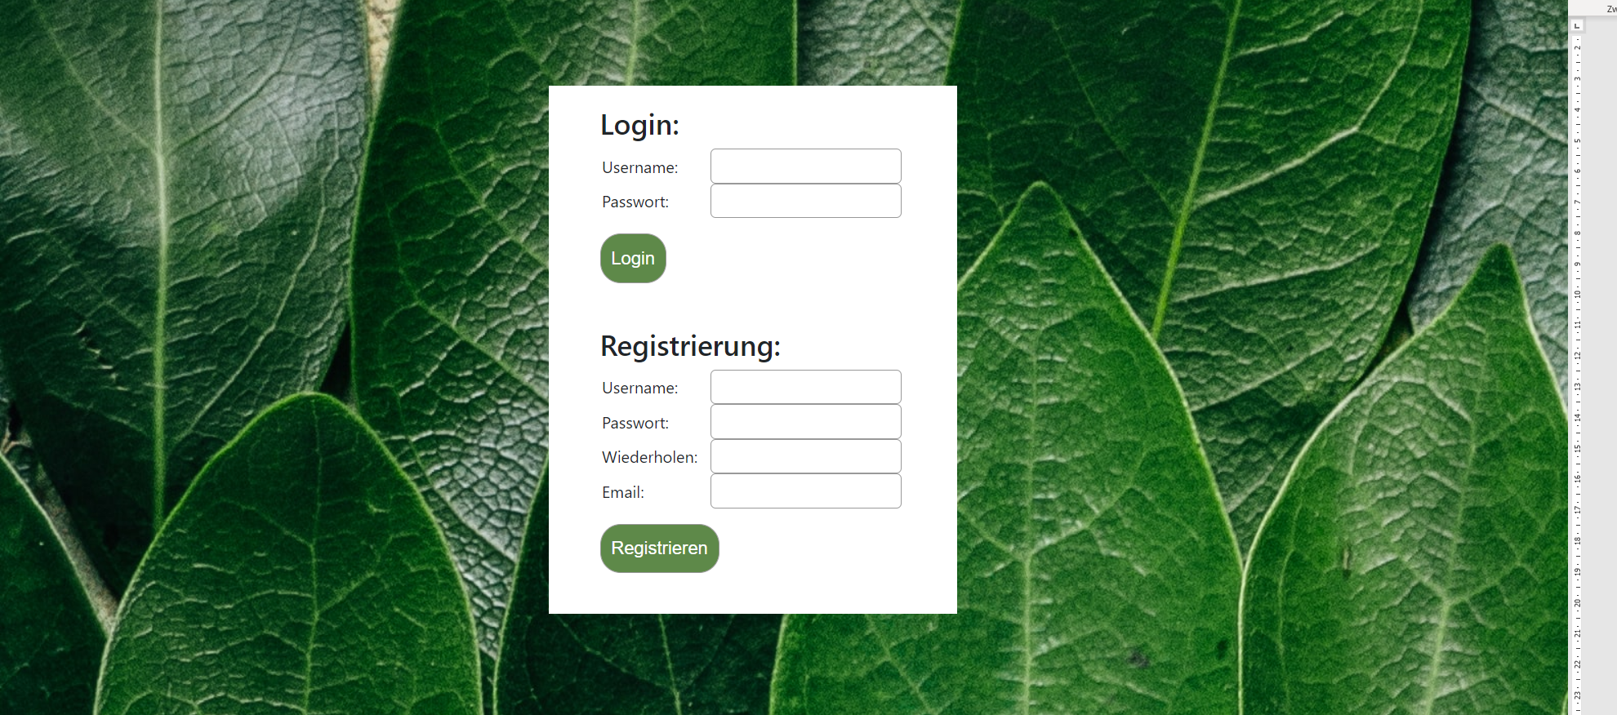

Fehlerfälle Registrierung

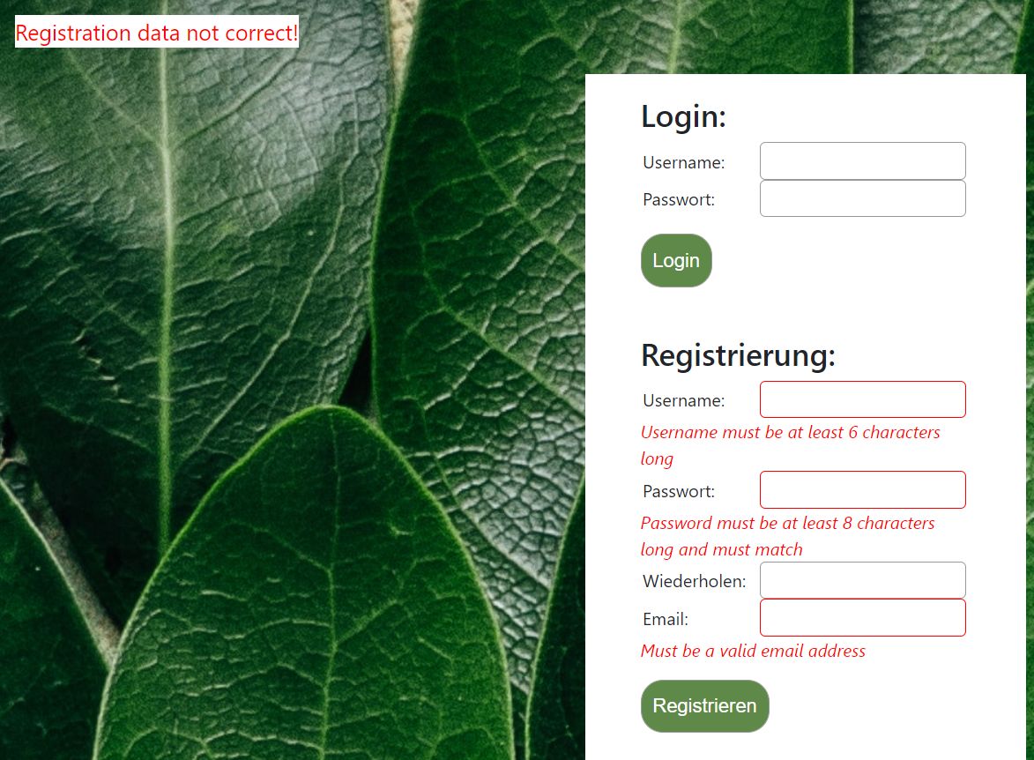

Erfolgreiches Registrieren

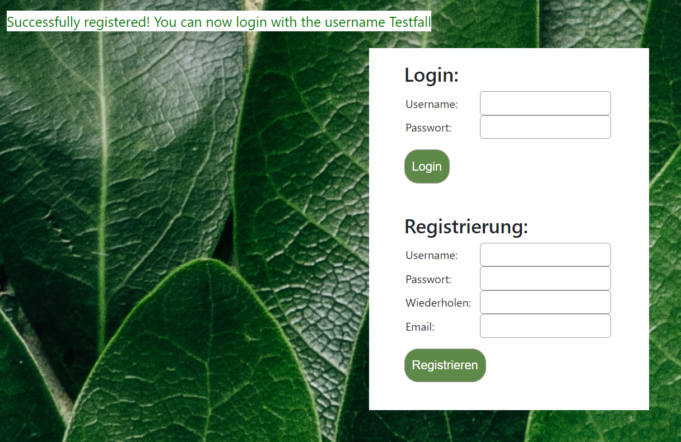

Login User: Sieht nur seine Einträge

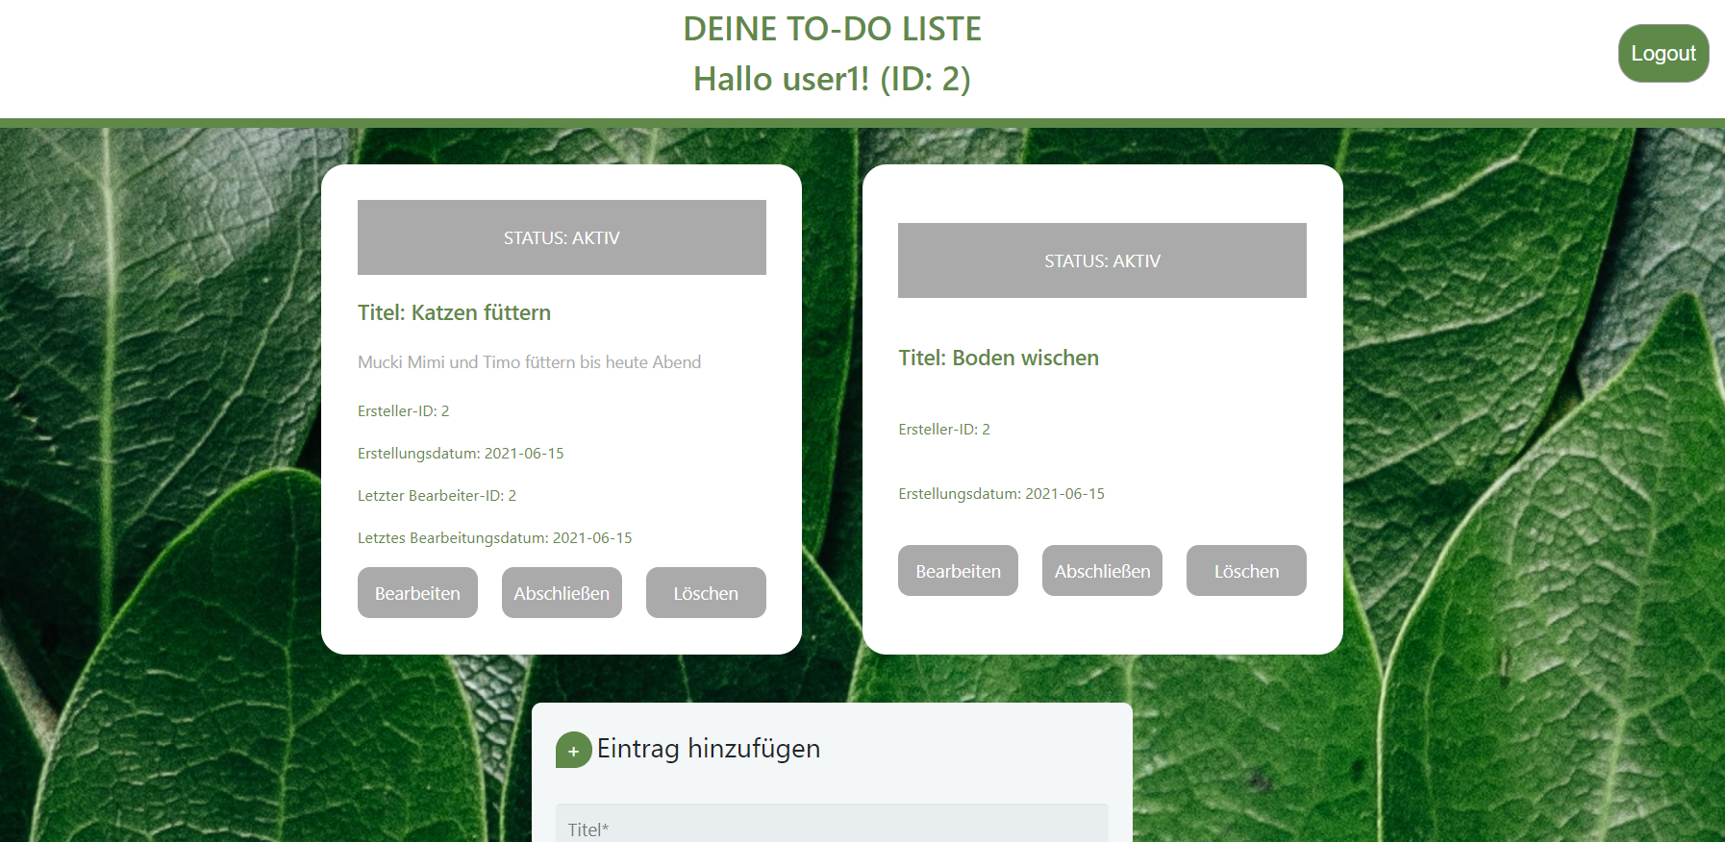

Login Admin: Sieht alle Einträge

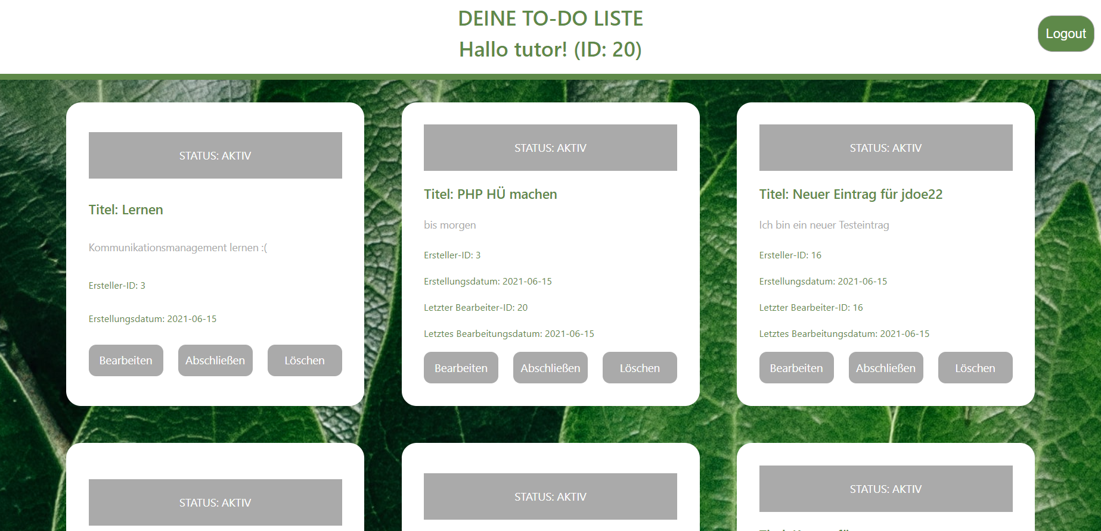

Eintrag bearbeiten: Eintrag hinzufügen ändert sich zu Eintrag bearbeiten, füllt sich mit derzeitigen Daten

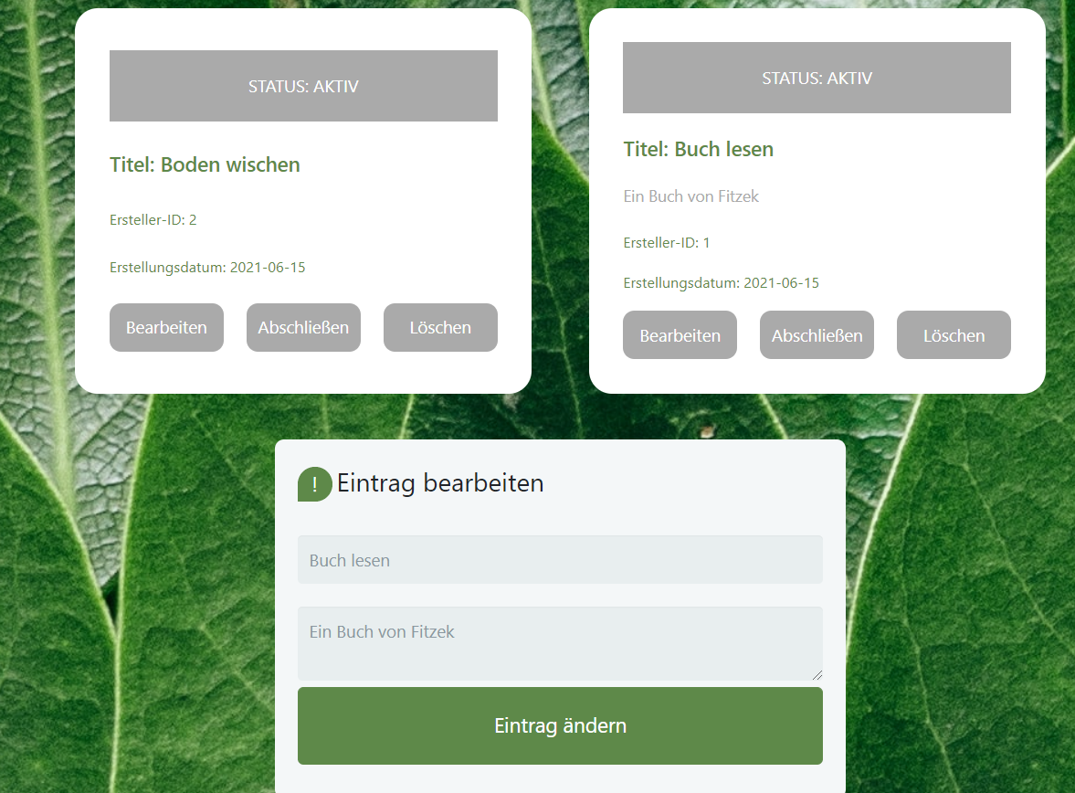

Eintrag abschließen: Kann man aber wieder reaktivieren

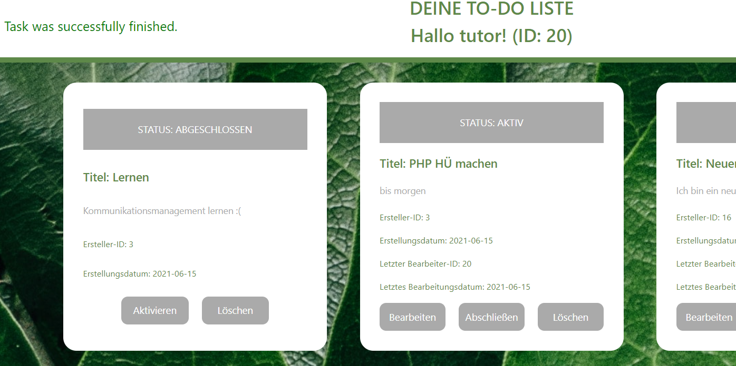

Task löschen

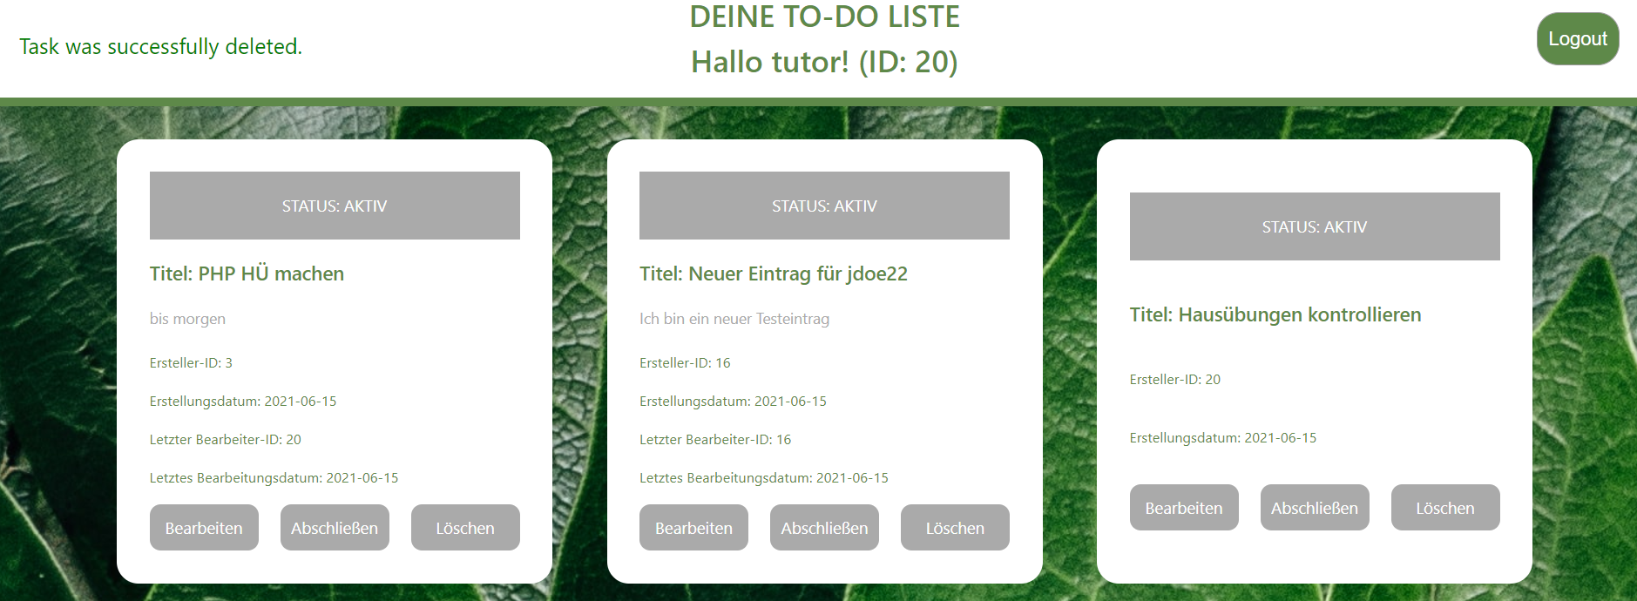

Task hinzufügen:

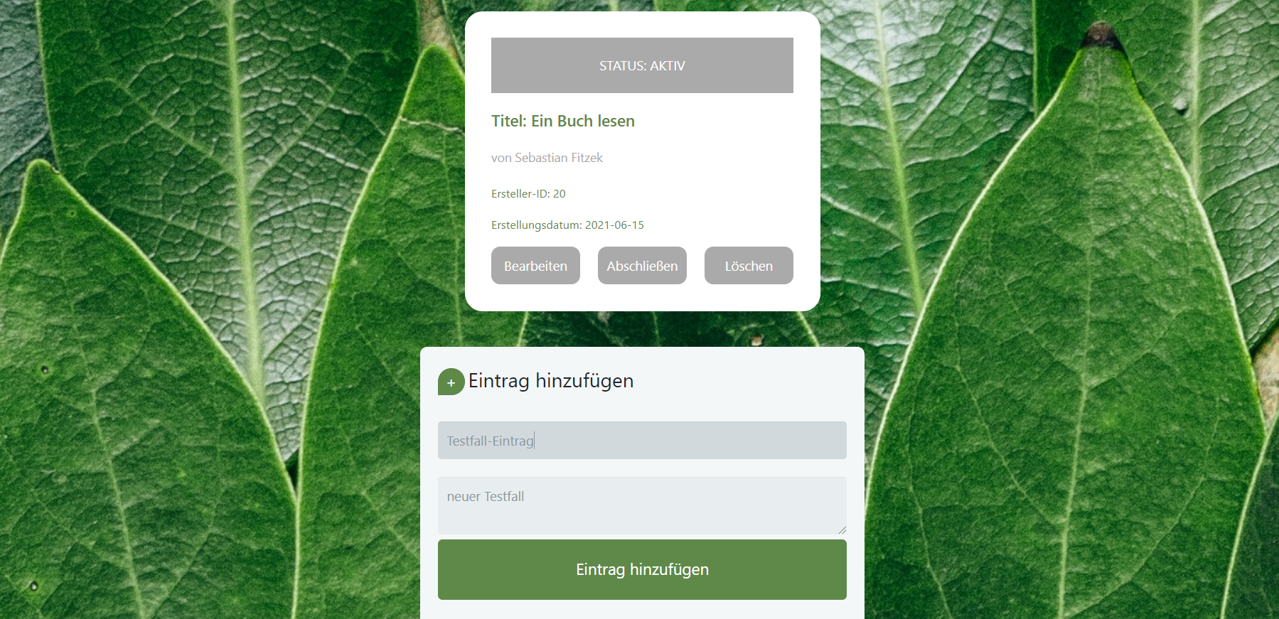

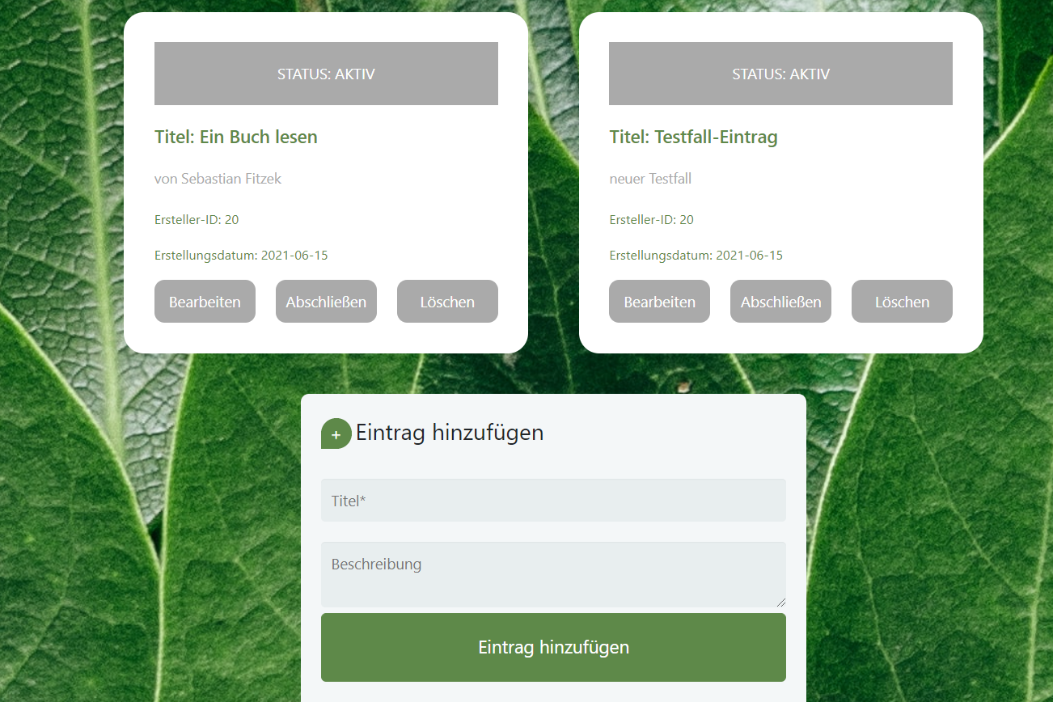

Doppelte Titel der Einträge verboten

